**Seramik - Journal of the Turkish Ceramics Society Authors Guide and Manuscript Preparation Template [times new roman 16]**

*Seramik - Journal of the Turkish Ceramics Society, V (N) p-p (YYYY)*

**Özgün Araştırma Makalesi / Original Research Article**

**Name Lastname1, Times New Roman2, 12 Punto2**

*1 University, Department, Zip Code, City, State, Country*

**Abstract**

Manuscripts submitted for consideration for publication in the Seramik - Journal of the Turkish Ceramics Society should contain an abstract with a maximum word count of 200. The text of the abstract should be written with times new roman font and 10 font size. The main numerical findings of the study are also presented in the abstract, but references and images should not be used. If abbreviations (ABB) are used in the abstract text, these abbreviations should be given when they are used for the first time.

*2 Company Ltd., Zip Code, City, State, Country*

**Sorumlu Yazar / Corresponding Author**

*Name Lastname*

*email@university.edu*

**Makale Bilgisi / Article Info**

*Sunulma / Received : GG AA YYYY*

*Düzeltme / Revised : GG AA YYYY*

*Kabul / Accepted : GG AA YYYY*

**Destekleyen Kuruluş / Funding Agency**

*Destekleyen Araştırma Kurumu*

*Proje #: xxxMxxx*

**Seramik - Journal of the Turkish Ceramics Society Yazım Kılavuzu ve Makale Şablonu [times new roman 14]**

**Anahtar Kelimeler**

*Anahtar*

*Kelimeler*

*3-5 adet*

*Times new roman 9*

*İtalik*

**Özet**

Seramik - Journal of the Turkish Ceramics Society dergisine sunulan makalelerin 200 kelimeyi aşmayan bir özet içermesi gerekir. Özet metni times new roman 10 punto ile yazılır. Özette çalışmanın başlıca sayısal bulguları da sunulur, kaynak ve görsel kullanılmaz. Özet metninde kısaltma (KST) kullanılıyorsa bu kısaltmalar ilk kez verildiklerinde açık halleri de verilmelidir.

**Keywords**

*Keyword 1*

*Keyword 2*

*Keyword 3*

*Keyword 4*

*Keyword 5*

**ORCID**

*Yazar Adı Soyadı*

https://orcid.org/????

*ISSN # 2718-0743* [*seramikdergisi.org*](https://seramikdergisi.org)

*ISSN # 2718-0743* [*seramikdergisi.org*](https://seramikdergisi.org)

**1 . INTRODUCTION[Times new roman 12 punto]**

The ***Seramik - Journal of the Turkish Ceramics Society*** journal started to be published in March 2020 as the periodical scientific publication of the Turkish Ceramics Society. It is published in e-journal format 4 issues per year. Original research articles and I invited review articles are published from the national and international scientific community. Articles are accepted in two languages ​​(Turkish and English). Articles submitted in Turkish should include English title and abstract, and vice versa articles in English should include Turkish title and abstract.

The articles submitted for publication in the journal should be prepared using the MS Word program in accordance with this template prepared in Word and the basic settings in the template should not be modified. The name of the article, the names and institutions of the authors, chapter titles, etc. should be written in the format in the template and in the prescribed font size using Times new roman font. Main section titles should be written in 12 points, capital letters and bold. The main text should be written in 9 points. The paragraphs should have a 6 points space after the paragraph. One line spacing should be left before the main titles.

The articles are expected not to exceed 10 pages. Authors should propose a running head not exceeding 75 characters for the article, which will appear in the upper right corner of the pages. References should be given sequentially in superscript numerical format in the text in the relevant places. The format of the references is different for articles1,2, books3,4 or internet resources5, and is described at the end of this guide.

|  |
| --- |
| In this box, the main purpose of the study should be expressed in a few sentences. |

**2. METHODS**

In the method section, the methods and chemicals used in the study should be given in detail. The purity and producer information of the chemicals should also be provided. For example, lead oxide - PbO (99.9% Alpha Aesar). If desired, the production flow chart can also be added to this section. The model and brand of the devices used in the characterization should also be specified. For example, Scanning Electron Microscope - SEM (XL 30 SFEG, FEI).

**3. RESULTS AND DISCUSSION**

***3.1. Sub Heading [Times new roman - italic 10]***

All the figures that are used in the article should be prepared in TIFF format and placed in the text as “in line with the text”. Reference should be made to the figure in the text (See Figure 1). Figure numbers should be written in bold in the figure captions. The figures should not contain machine generated text and signs. As shown in Figure 1, micron bar should be added to SEM micrographs. The font size used in the figures should be compatible with the text and legible. As seen in Figure 2, peaks should be indexed in XRD patterns. The PDF card number used to identify the phase and to index the peaks should also be provided.

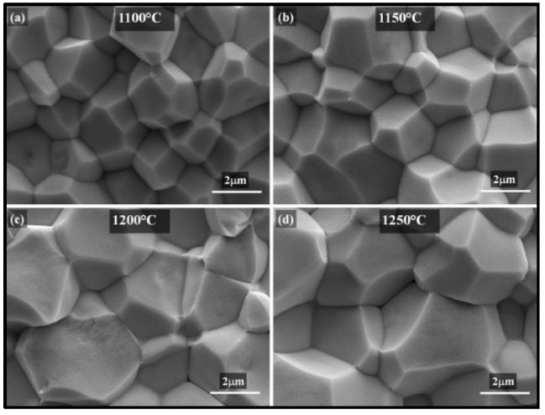

**Figure 1.** Scanning electron microscope images of samples sintered at different temperatures, (a) 1100°C, (b) 1150°C, (c) 1200°C, (d) 1250°C.

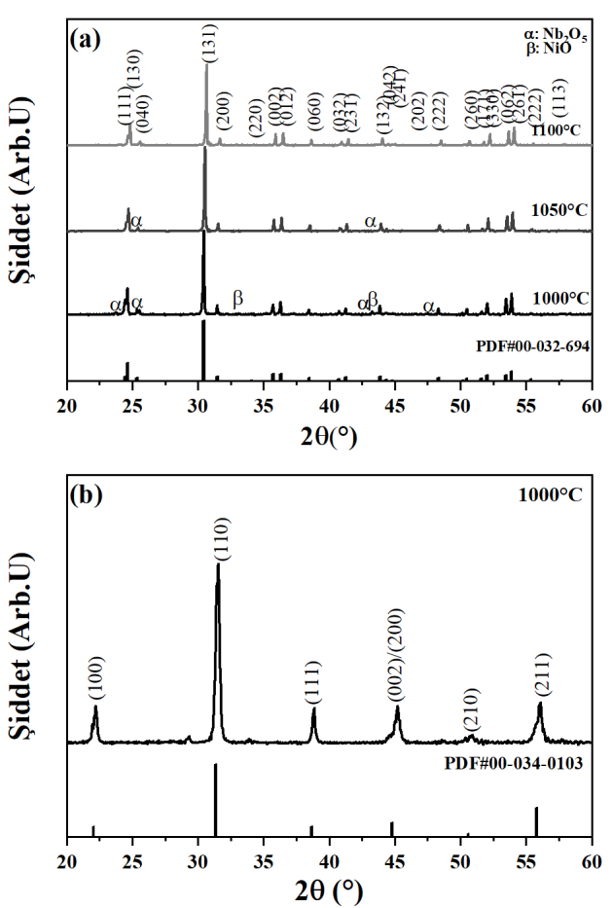

**Figure 2.** XRD patterns of (a) NiNb2O6 calcined at various temperatures, (b) 0.5PNN-0.15PZ-0.35PT ceramic composition calcined for 4 hours at 1000°C.

When the equation needs to be used in the text, the equations can be prepared using the Equation Editor in MS Word or similar programs. Equations must be given in the text numbered and aligned to the right.



Tables should be placed in the relevant places within the text in the format “in line with text”. Only horizontal lines should be used in the tables, not vertical lines. The line spacing in the table should be “single line spacing”. Sample format is given below.

**Table 1.** Measured properties.

|  |  |  |  |
| --- | --- | --- | --- |
| **Property** | **Sample A** | **Sample B** | **Sample C** |
| Elongation (%) | 16 | 18 | 20 |
| Density (g/cm3) | 4,0 | 4,2 | 4,4 |

**4. CONCLUSIONS**

The conclusion is a text of 1-2 paragraphs, including the numerical results and short comments of the study. At the end of this text, the most important and striking results, i.e. highlights of the study should be given in the box with 2-5 short sentences.

|  |
| --- |
| In this box  · The most important and striking results of the study  · Should be given in 2-5 short sentences. |

**Acknowledgement**

Persons or institutions who do not deserve to be included as a writer with limited contributions to the study in terms of measurements or discussion etc can be acknowledged under this separate heading. Since the financial support is already acknowledged in the first page, there is no need to re-acknowledge it here in this section.

**References**

[1]  F. Lastname, N. Surname, “Full name of the article”, *Full name of the Journal*, **Vol No** (Issue No), Pp-Pp (Year).

[2] M. Algueró, C. Alemany, L. Pardo, A.M. González, “Method for obtaining the full set of linear electric, mechanical, and electromechanical coefficients and all related losses of a piezoelectric ceramic.” *Journal of the American Ceramic Society***, 87** (2), 209-215 (2004).

[3]  N. Surname, “Chapter title” *Full Name of the Book*. F. Lastname (Editor), Publisher, Pp-Pp (Year).

[4] D. Damjanovic, “Lead-based piezoelectric materials” in *Piezoelectric and Acoustic Materials for Transducer Applications.* A. Safari, E. K. Akdoğan (editors), Springer, 59-79 (2008).

[5]  IEEE, 1988. Standard on Piezoelectricity. *https://ieeexplore.ieee.org/document/26560* (erişim tarihi: 01/01/2020).